**PC Tracker & Land Registry Portal Update**

**Login**:

**Tracker** – Login to Tracker <https://tltracker.anzaservicesllp.com/> with provided credentials. Select edit record under post completion.

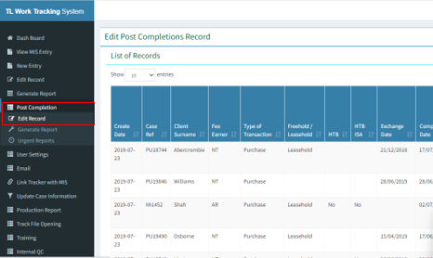

**Land Registry** – Login to LR portal <https://eservices.landregistry.gov.uk/eservices/HomePageRouter> with provided credentials. Select “NEW: View Application” under services.

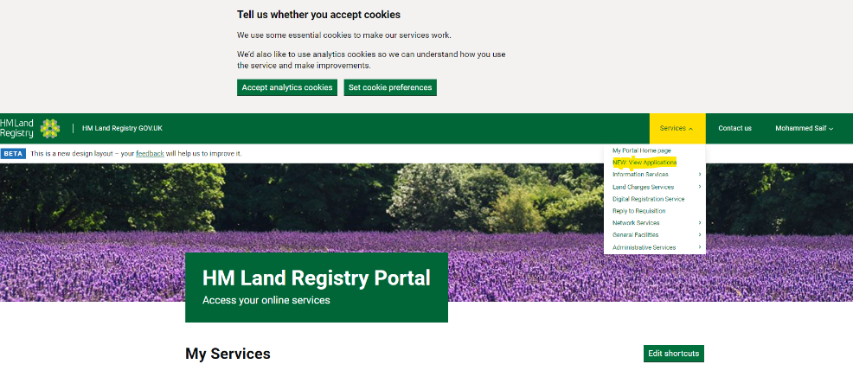

1. Click on “Generate Report” under post completion and select search by “COR not Received” & transaction type “All” and export the report. Copy the case reference in the sequence from the tracker and search it on the LR portal.

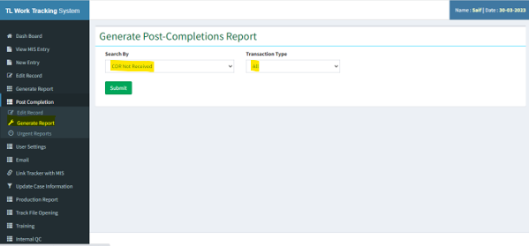

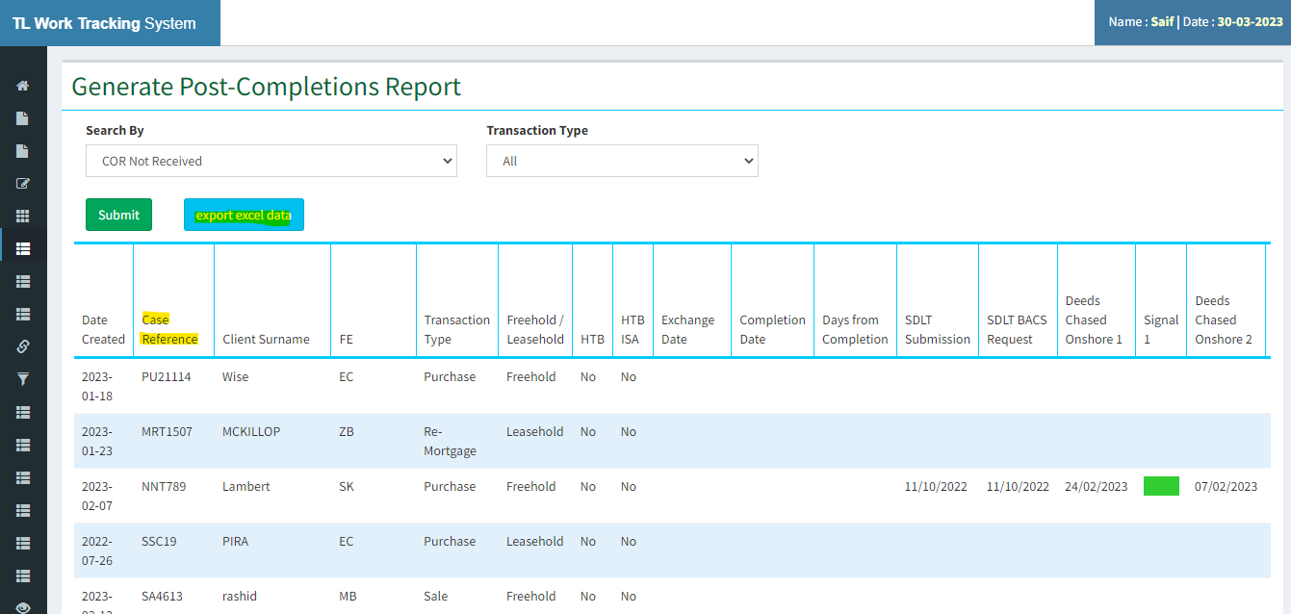

2. On LR portal when you select “NEW: View Application” under services, please tick “Customer Reference” and put the reference copied from the tracker report.

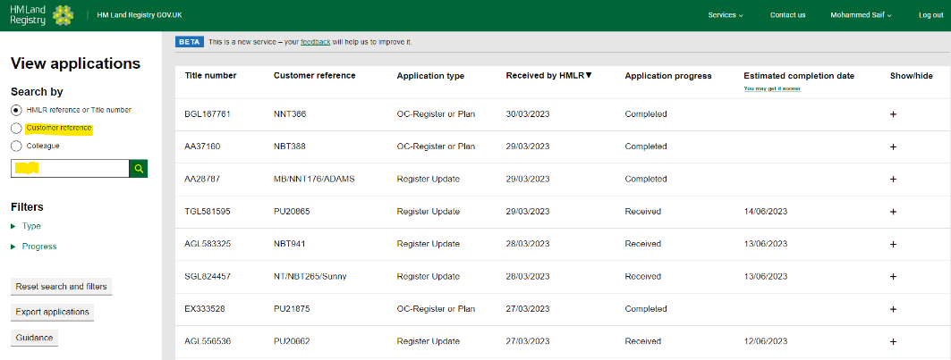

3. Once you find the case reference on LR portal please click on the “+” sign and you will have the case status.

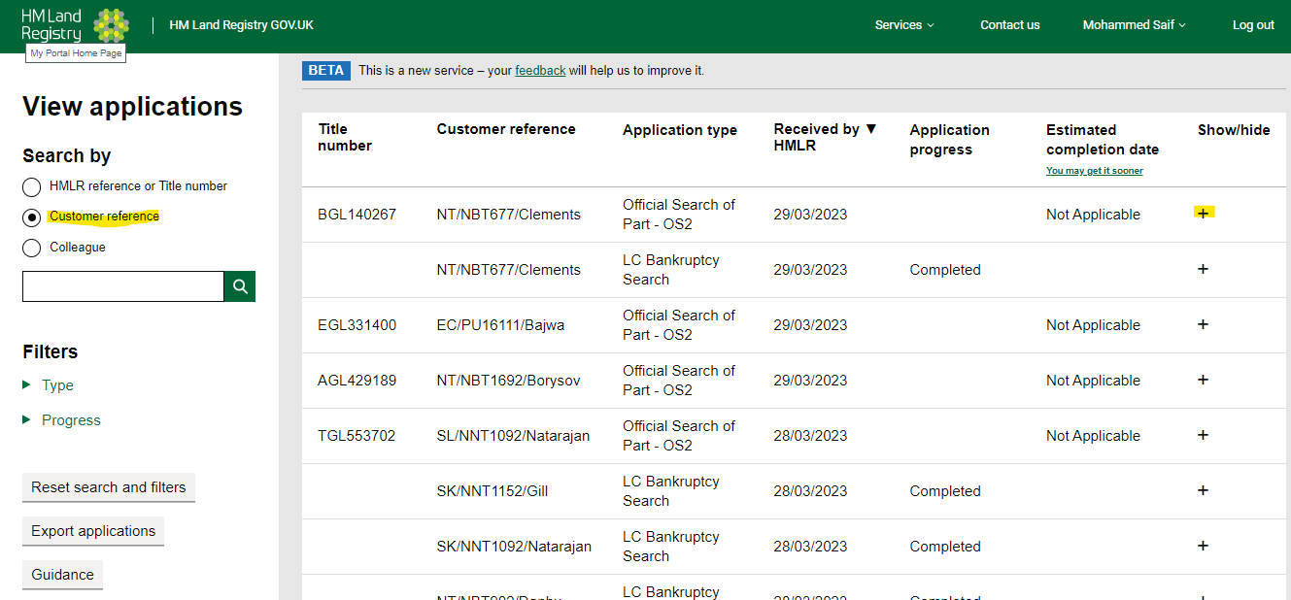

4. Once the tracker case reference matches with the LR portal file. We must check the application type and pick only the application types mentioned below and extract the title number, Ap1 Submission date (Received by HMLR), and Estimated completion date from the heading.

* **Register update**
* **New Lease**
* **Transfer of Part**
* **Lease Extension**
* **Official Search of Part – OS2**
* **Official Search of Whole – OS1**
* **Cancellation of Official Search of Part – OS2**

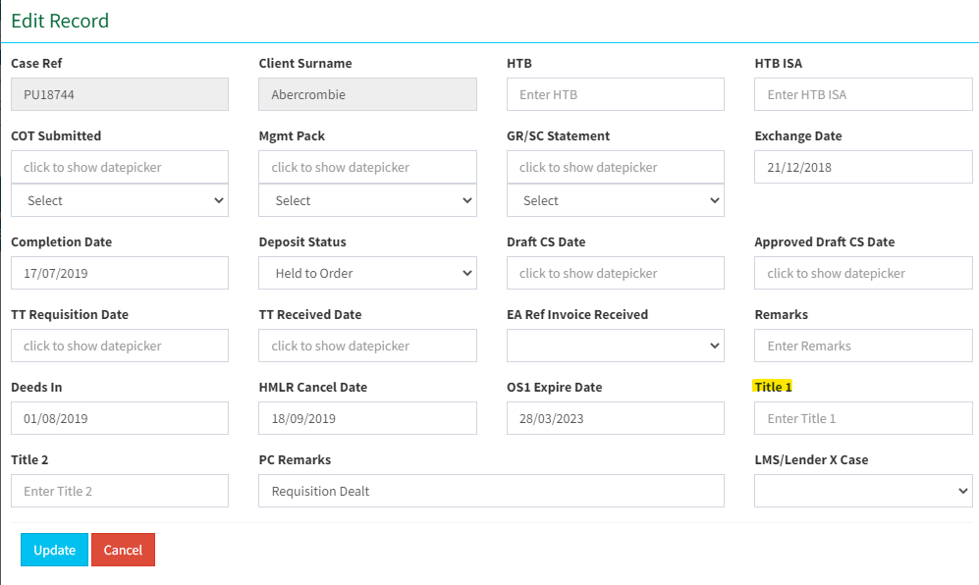

4.1 **Application submitted & pending, and no requisition received on Register update, New Lease, Transfer of part, and Lease Extension**.

The below screen will appear when there is no requisition received and the application is still pending at the LR portal. We have to extract details from the application progress – details and update it on the tracker as the application is active. PC remark must be “Application Pending at LR”.

Please update the tracker with “Next Review Date” for every 28th Day.

Below tabs to be changed –

AP1 Submitted – Received by HMLR

Estimated date from HMLR – estimated completion date

Next review date – add 28 days from today

PC remark - Application Pending at LR

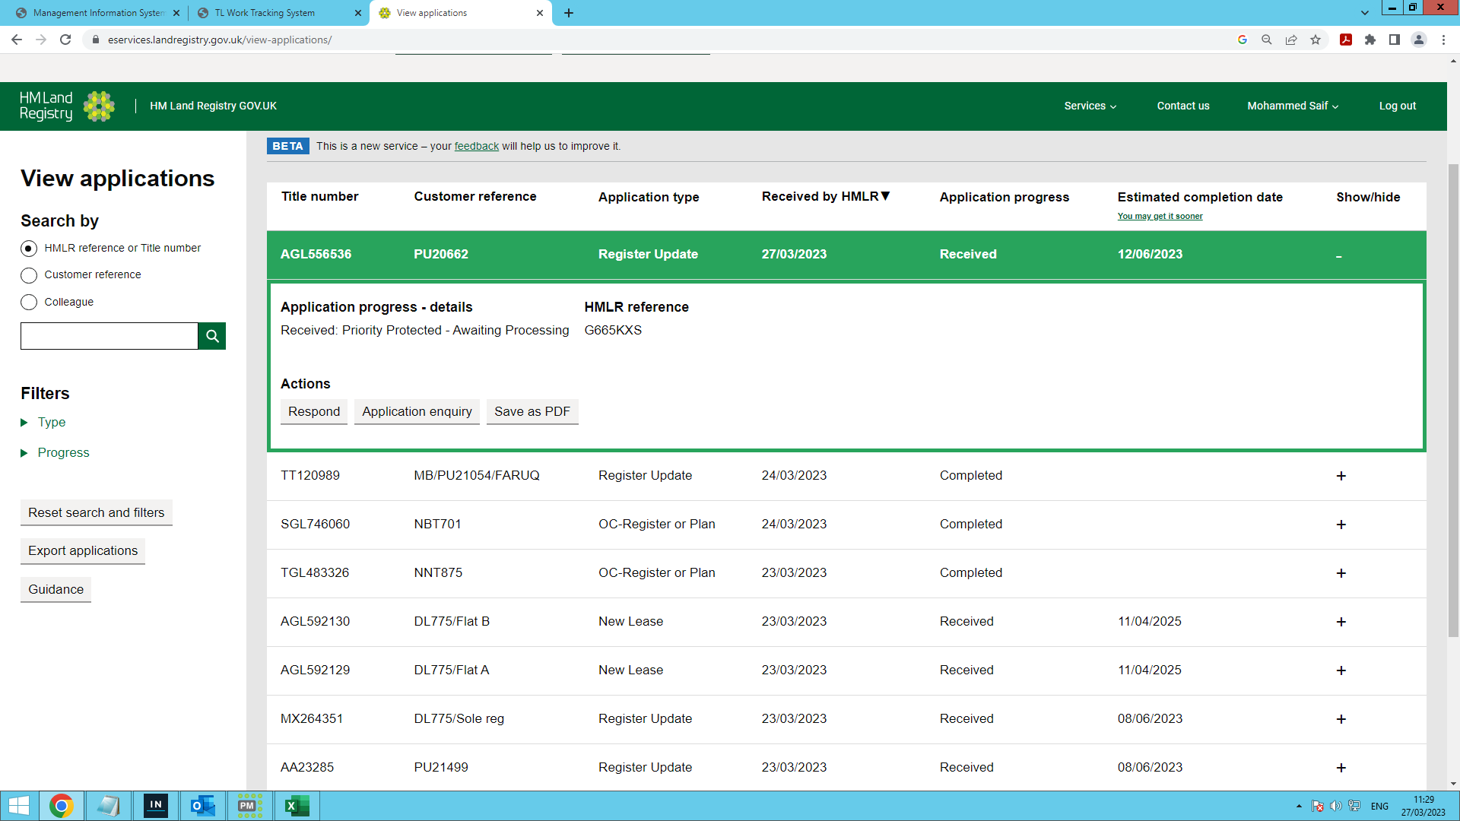

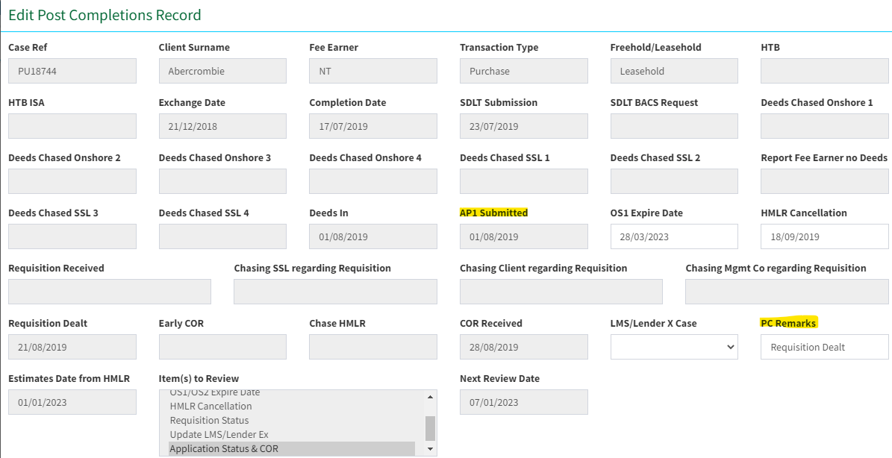

4.2 **Application submitted & pending with requisition received on Register update, New Lease, Transfer of part, and Lease Extension**.

The below screen will appear when there is a requisition received and the application is still pending at the LR portal. We have to extract details from the application progress – details and requisition issued date on the tracker and mark the case as active. PC remark must be “Requisition Received”.

Please update the tracker with “Next Review Date” for every 7th Day.

Below tabs to be changed –

AP1 Submitted – Received by HMLR

Requisition received – requisition issued on “date “

Estimated date from HMLR – estimated completion date

Next review date – add 7 days from today.

PC remark - Application Pending at LR

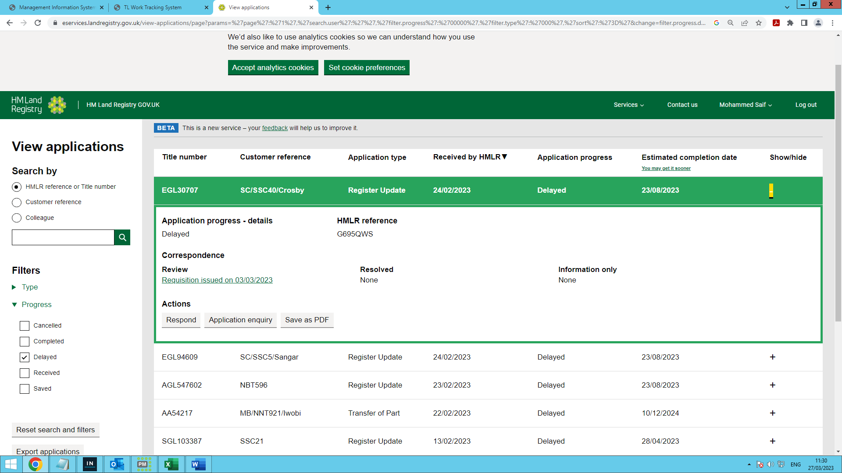

4.3 **Application completed on Register update, New Lease, Transfer of part, and Lease Extension**.

The below screen will appear when we receive the completion of registration. Download the COR documents, save them in the file, and send it to ops for checking. Also. Update the PC tracker with the application completed and remarks must be “COR Received.

Below tabs to be changed –

PC remark – COR received

COR received – todays date

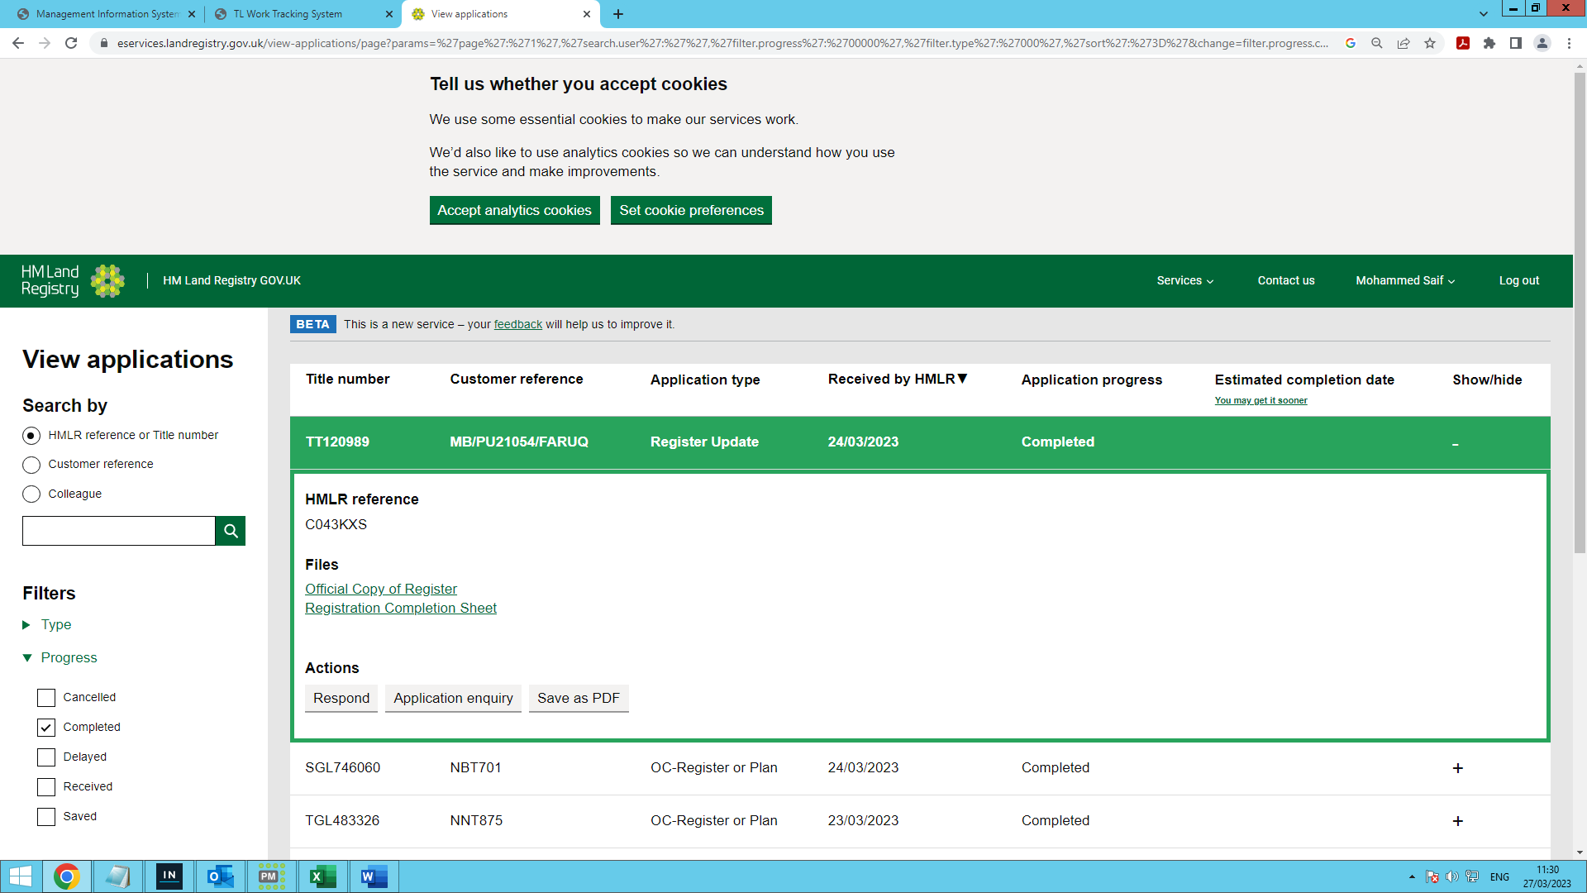

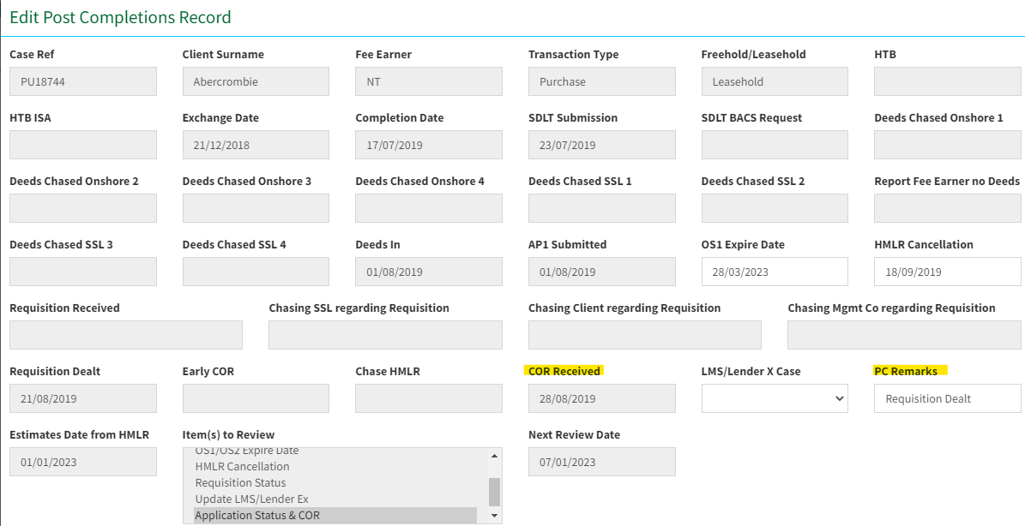

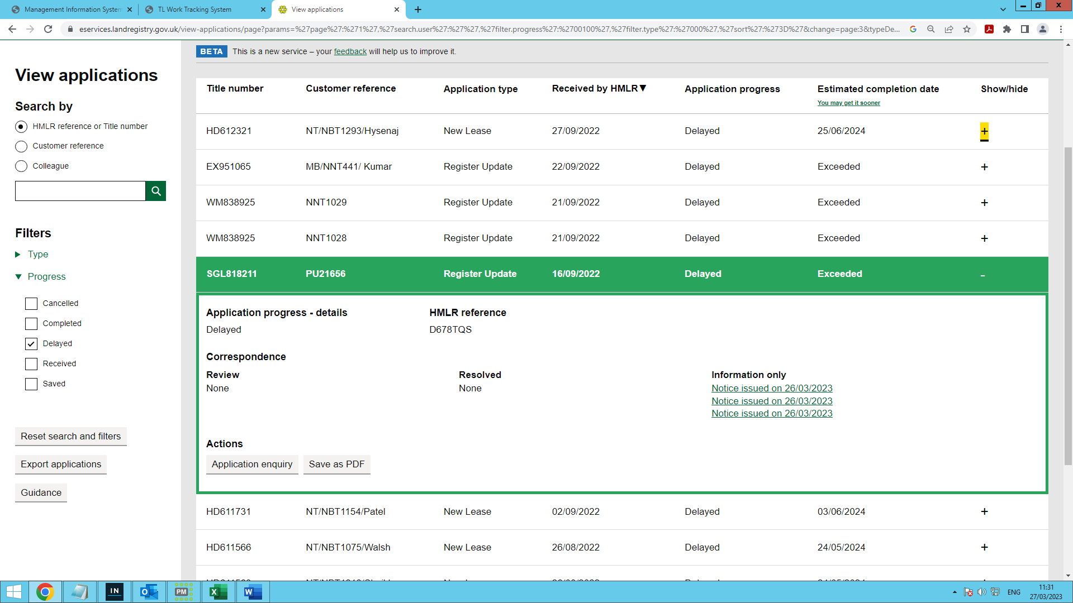

4.4 **Application cancelled at Land Registry on Register update, New Lease, Transfer of part, and Lease Extension**.

The below screen will appear when the application is cancelled. Email the ops team regarding the same. Update the tracker as the application is Cancelled and the PC remark must be “Application Cancelled”.

Please update the tracker with “Next Review Date” for every 7th Day.

Below tabs to be changed –

PC remark - “Application Cancelled”.

Next review date – add 7 days from today

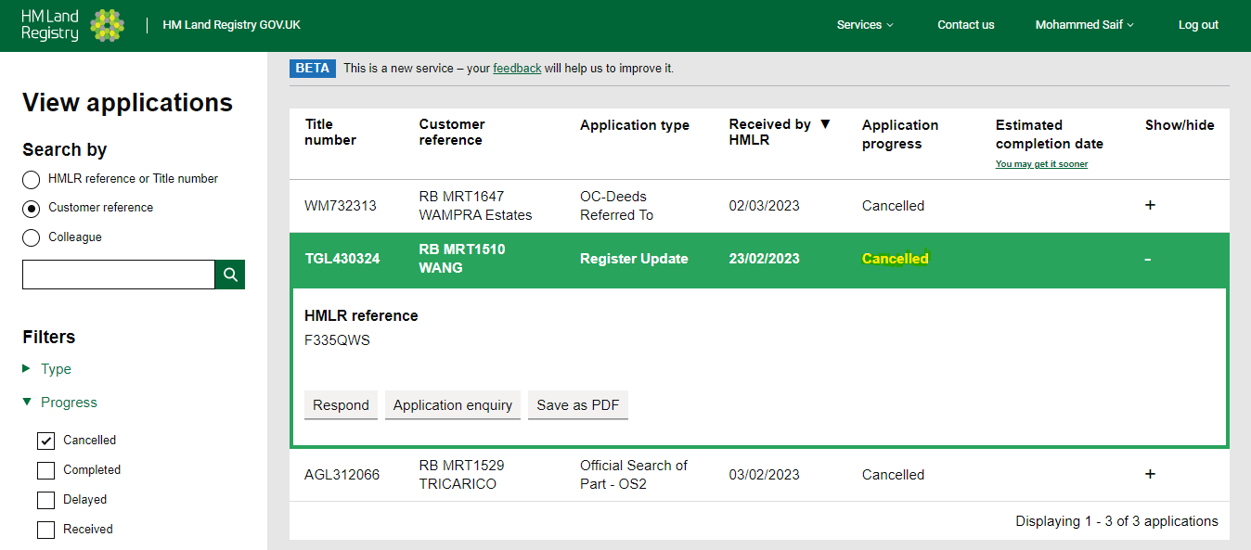

4.5 **Application submitted & pending with warning of cancellation received on Register update, New Lease, Transfer of part, and Lease Extension**.

The below screen will appear when there is a warning of cancellation received and the application is still pending at the LR portal. We must extract details from the application progress – details and warning of cancellation date on the tracker and mark the case as active. PC remark must be “Warning of cancellation Received”.

Please update the tracker with “Next Review Date” for every 15th Day.

Below tabs to be changed –

HMLR Cancellation – add the cancellation date from warning of cancellation issued

PC remark - Warning of cancellation Received

Next review date – add 15th Day from today

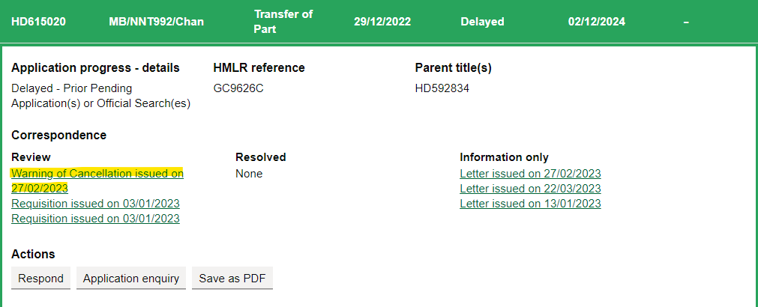

4.6 **Official search of whole and part with priority.**

The below screen will appear when there is an official search in place. We must update the priority period date on the tracker. Also, the PC remark should be “OS1/OS2 in place”.

Please update the tracker with “Next Review Date” every 3 days prior to the expiry date.

Below tabs to be changed –

OS1 expiry date – add priority protected date

PC remark – “OS1/OS2 in place”.

4.7 **Cancellation of official search of part with priority.**

The below screen will appear when the official search is cancelled. The ops team should get an email regarding the same. Also, the PC remarks should be “OS Search Cancelled”.

Below tabs to be changed –

PC remark - “OS Search Cancelled”.

***Please note if we are receiving more than 1 case on the HMLR portal then BOT needs to send an email to the team showing the same error.***